**Lab 2 Tasks**

Task 1:

Output for task 1 (swapping values).

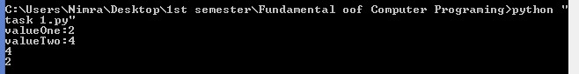

Task 2:

Output for task 2 (sum and average)

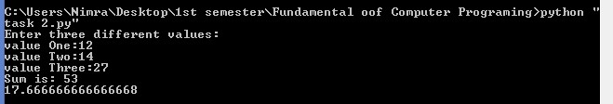

Task3:

Output for task 3 (Circumference of circle).

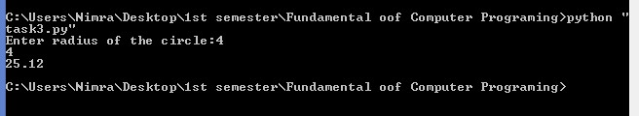

Task 4:

Output for task 4 (three spaces in digits).

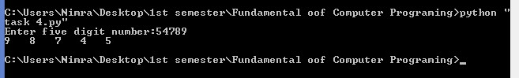

Task 5:

Output for task 5 (numbers, squares, cubes).

